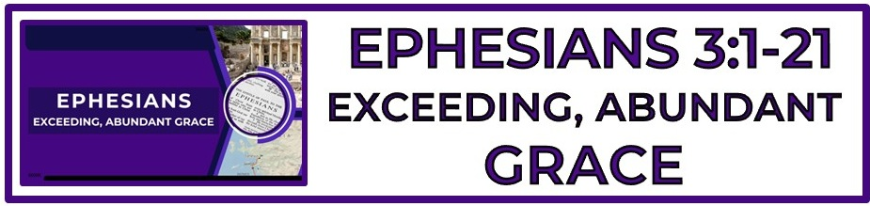

The Bottom Line:
By ________________ Of ____________ We Are Washed, Empowered, Invited And Loved.

Whatever the believers background, we are all made one _________ _____________. (VS 1)

Dispensation (VS 2)
Oikonomia (Strong’s G3622)
I. the management of a household or of household affairs
1.specifically, the management, oversight, _____________________, of other's property
2. the office of a manager or overseer, __________________

The mysteries of God are those things which were hidden or not fully known in the Old Testament but have been _______________ through the ministry of Christ and the revelation of the Holy Spirit. (VS 3)

What is the _____________? (VS 6, 1 Corinthians 15:1-8)

1. Christ died for our sin according to the scriptures (Psalm 22, Isaiah 53)

2. Christ was buried (Matthew 27:57-60, Mark 15:42-26, Luke 23:50-54, John 19:38-42)

3. Christ rose again on the third day according to the scriptures (Matthew 28, Mark 16, Luke 24, John 20-21, Psalm 16:10, Matthew 12:39-40, Genesis 22:1-19)

4. That He was witnessed to be alive by many (1 Corinthians 15:5-8)

5. Those who believe in Christ will also be raised from the dead (1 Corinthians 15:20-22)

6. The resurrected will live with God in an eternal state of paradise (1 Corinthians 15:23-57)

The gospel is the ___________ by which the believer is saved and the _________ in which they stand. (VS 6)

God’s call on each life is initiated by ____________ and __________ by the working of The Holy Spirit.
(VS 7, Acts 1:8)

God uses His church to reveal His wisdom to the principalities and powers as: (VS 10-11)

1. A demonstration of God’s __________________ in His wisdom (1 Peter 1:12)

2. A declaration of Christ’s ______________ over all spiritual beings (Colossians 2:10)

3. A show of His complete ________________ over all created beings (1 Corinthians 15:20-28)

____________ redeemed believer is evidence of the manifold wisdom of God. (VS 10-11)

The same faith which saves the sinner opens the door to the _____________ ___________ of heaven. (VS 12, Ephesians 2:18, Hebrews 4:16, 10:19)

The believer’s supply of power is not sourced in finite human ability but in God’s _______________ glory. (VS 16-17, Psalm 62:11, 1 Chronicles 29:11, Matthew 28:18, Revelation 19:11, Matthew 28:18)

God’s power is realized in the believer through ______________ in The Holy Spirit. (VS 16-17)
Notes:
________________________________________________________________________________________________________________________________________________________________________________________________________________________________________________________________________________________________________________________________________________________________________________________________________________________________________________________________________________________________________________________________________________________________________________________________________________________________________________________________________________________________________________________________________________________________________________________________________________________________________________________________________________________________________________________________________________________________________________________________________________________________________________________________________________________________________________________________________________________________________________________________________________________________________________________________________________________________________________________________________________________________________________________________________________________________________________________________________________________________________________________________________________________________________________________________________________________________________________________________________________________________________________________________________________________________________________________________________________________________________________________________________________________________________________________________________________________________________________________________________________________________________________________________________________________________________________________________________________________________________________________________________________________________________________________________________________________________________________________________________________________________________________________________________________________________________________________________________________________________________________________________________________________________________________________________________________________________________________________________________________________________________________________________________________________________________________________________________________________________________________________________________________________________________________________________________________________________________________________________________________________________________________________________________________________________________________________________________________________________________________________________________________________________________________________________________________________________________________________________________________________________________________________________________________________________________________________________________________________________________________________________________________________________________________________________________________________________________________________________________________________________________________________________________________________________________________________________________________________________________________________________________________________________________________________________________________________________________________________________________________________________________________________________________________________________________________________________________________________________________________________________________________________________________________________________________________________________________________________________________________________________________________________________________________________________________________________________________________________________________________________________________________________________________________________________________________________________________________________________________________________________________________________________________________________________________________________________________________________________________________________________________________________________________________________________________________________________________________________________________________________________________________________________________________________________________________________________________________________________________________________________________________________________________________________________________________________________________________________________________________________________________________________________________________________________________________________________________________________________________________________________________________________________________________________________________________________________________________________________________________________________________________

