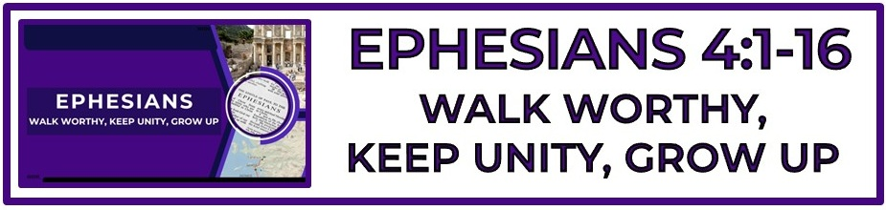
The Bottom Line:
To Know Who I Am In Christ Allows Me To ___________ As I Should In Christ.

It is not possible to understand how to ___________ with Christ (CHS 4-6) until we have comprehended where we __________ with Christ. (VS 1, CHS 1-3)

Worthy: To hold ____________ _____________ (VS 1)

To walk worthy is a _______________ to the love of God, not a ____________ for the love of God. (VS 1)

Endeavoring (VS 3)
Spoudazō (Strong’s G4704)
I. to hasten, make haste
II. to exert one's self, endeavor, ___________ ________________

Keep (VS 3)
Tēreō (Strong’s G5083)
I. to attend to carefully, take care of
1. to ____________

Each believer is tasked with the work of __________________ Christ’s blood bought unity and peace in the body of Christ. (VS 3)

Seven essentials of Christian ____________ (VS 4-6)
1. One body: The church (All believers all over the world)
2. One Spirit: The Holy Spirit by whom Christ rules and leads His body.
3. One hope: The common future of all believers in heaven with God.
4. One Lord: Christ through who’s body we enter into faith. (1 Corinthians 11:23-26)
5. One faith: The message of The Gospel
6. One baptism: Baptism OF Holy Spirit (1 Corinthians 12:13) or water baptism.
7. One God and Father: The sovereign God over all who chooses to live in and through us by means of the cross of Christ and the work of The Holy Spirit.

Christian unity does not equal _________________ or ________________. (VS 4-6, VS 7-11, Romans 12:3-8, 1 Corinthians 12)

The grace of God which saves is the same grace which gifts and empowers for ______________. (VS 7)

Christ _______________ on high: Christ ascended into heaven after conquering Satan, demons, sin, death and the grave. (VS 8-9, Acts 1:9-11, Colossians 2:15)

Christ ________________: Differing Views (VS 8-9)

1. Christ’s Incarnation: Christ descended to earth becoming flesh. He lived, was crucified, buried, resurrected and ascended to heaven again. (John 1:14, 3:13, 6:38)

2. Christ’s descent into Hades: “Lower parts of earth” is reference to Christ’s spirit which went to the underworld between death and resurrection (Luke 16:19-31, 1 Peter 3:18–20; Acts 2:27, 31). He proclaimed victory and released OT saints, and they went to heaven.

Equipping (VS 12)
Katartismos (Strong’s G2677)
Complete furnishing

Comes from Katartizō (Strong’s G2675)
I. to render, i.e. to fit, sound, complete
1. to ___________ (what has been broken or rent), to ____________

Tossed to and fro: (VS 14)
Klydōnizomai (Strong’s G2831)
I. to be tossed by the ____________
II. metaph. to be agitated (like the waves) _______________

Every believer has a place in the body of Christ and without each one the body will not ___________ and _____________ as it should.

NOTES:
__________________________________________________________________________________________________________________________________________________________________________________________________________________________________________________________________________________________________________________________________________________________________________________________________________________________________________________________________________________________________________________________________________________________________________________________________________________________________________________________________________________________________________________________________________________________________________________________________________________________________________________________________________________________________________________________________________________________________________________________________________________________________________________________________________________________________________________________________________________________________________________________________________________________________________________________________________________________________________________________________________________________________________________________________________________________________________________________________________________________________________________________________________________________________________________________________________________________________________________________________________________________________________________________________________________________________________________________________________________________________________________________________________________________________________________________________________________________________________________________________________________________________________________________________________________
____________________________________________________________________________________________________________________________________________________________________________________________________________________________________________________________________________________________________________________________________________________________________________________________________________________________________________________________________________________________________________________________________________________________________________________________________________________________________________________________________________________________________________________________________________________________________________________________________________________________________________________________________________________________________________________________________________________________

