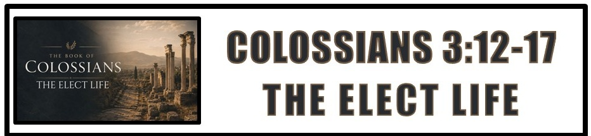
The Bottom Line:
Live Like You’re _____________!

The “____________ of God” are those who respond in faith to God’s gracious call and are thereby chosen as His holy, beloved children in Christ. (VS 12)

The __________________ of election: (VS 12)

1. Elect: We are chosen by God to be His children by grace through faith.

2. Holy: The elect are called and empowered to live holy lives. (Sanctification) (Acts 1:8, Eph 2:8-10)

3. Beloved: The elect, those chosen by God through faith are loved by Him.

4. Put on: Those who are elect, holy and loved will “put on” a Spirit-led lifestyle of mercy, kindness, humility, meekness and patience. (Galatians 5:22-23)

Election isn’t simply a confession of faith; it is the ___________________ of a life in Christ. (VS 12)

Bearing (VS 13)
Ancechomai (BDAG)
Endure, bear with, put up with, _____________

The elect don’t ______________ grudges, they _____________ grace. (VS 13)

Bond (VS 14)
Syndesmos (CDWGTHB)
Joint tie, _______________, uniting principle,

What drives and holds mercy, kindness, humility, meekness, long suffering and forgiveness together? ___________! (VS 14, Proverbs 10:12, 1 Peter 4:8)

Love is the ligament of Christian character. Christian character is the ligament of the ___________ of _____________. (VS 14, Ephesians 4:16)

Rule (VS 15)
Brabeuō (LSJ)
Act as judge, _____________, preside

When love binds our character, ______________ ____________ rules the heart. (VS 15)

A heart ruled by the peace of Christ becomes a _______________, not a burden, to the Body of Christ. (VS 15)

The _____________ of Christ flows from the ___________ of Christ! (VS 16)
Making The Word _________ ___________ in your life: (VS 16)

Teaching: Positively imparting truth that builds up, instructs, and encourages.

Admonishing: Caring correction and warning (as a coach correcting for success)

Psalms: Singing the actual Psalms of Scripture (God’s Word set to music).

Hymns: Doctrinal songs and songs of worship that declare who God is.

Spiritual Songs: Spontaneous, Spirit-led songs that come from the heart.

In Christ there is no _____________ and ______________. Our whole lives reflect our identity or lack of identity as the elect of God. (VS 17)

Notes:
________________________________________________________________________________________________________________________________________________________________________________________________________________________________________________________________________________________________________________________________________
______________________________________________________________________________________________________________________________________________________________________________________________________________________________________________________________________________________________________________________________________________________________________________________________________________________________________________________________________________________________________________________________________________________________________________________________________________________________________________
______________________________________________________________________________________________________________________________________________________________________________________________________________________________________________________________________________________________________________________________________________________________________________________________________________________________________________________________________________________________________________________________________________________________________________________________________________________________________________
______________________________________________________________________________________________________________________________________________________________________________________________________________________________________________________________________________________________________________________________________________________________________________________________________________________________________________________________________________________________________________________________________________________________________________________________________________________________________________
______________________________________________________________________________________________________________________________________________________________________________________________________________________________________________________________________________________________________________________________________________________________________________________________________________________________________________________________________________________________________________________________________________________________________________________________________________________________________________
________________________________________________________________________________________________________________________________________________________________________________________________________________________________________________________________________________________________________________________________________________________________________________________________________

