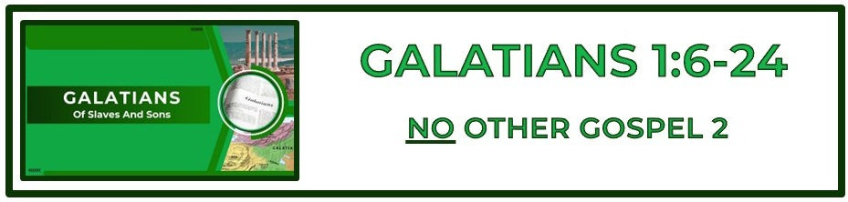

**Outline:**

**I. Introduction and explanation of Paul’s authority (1:1-2:21)**

**II. Explanation of justification through faith (2:1-4:31)**

**III. Explanation of the sanctifying work of The Holy Spirit and Christian liberty (5:1-6:15)**

**IV. Conclusion (6:16-18)**

**The Bottom Line:**

**There Is No Other Gospel Than Salvation by ____________**

**Through ____________ in Christ!**

**Turning away (VS 6)**

*Metatithēmi (Strong’s G3346)*

*to transpose (two things, one of which is put in place of the other)*

*to fall away or* ***_____________*** *from one person or thing to another*

**Accursed (VS 8-9)**

*Anathema (Strong’s G331)*

*a thing devoted to God without hope of being redeemed, and if an animal, to be slain; therefore a person or thing* ***_______***

*to destruction*

*1. a curse*

*2. a man accursed, devoted to the direst of woes*

The pursuit of human approval will eventually, if not immediately, _________________ commitment to Christ. **(VS 10)**

The _____________ is not a religion formed in the mind of man. It is the divine purpose of God the Father, unveiled through the life, death, and resurrection of Christ to those who will believe. **(VS 11-12)**

God weaves all of our life experiences, both the triumphs and tragedy, into His _____________ for His ____________. **(VS 15-16)**

Each of us is fashioned with a _____________ ______________. A divine design which not only brings God glory but satisfies our deepest desires. **(VS 15-16)**

**Life Group Application Questions**

**1. How can we rightly discern between what is the true gospel and what is false teaching? (VS 6-9)**

**____________________________________________________________________________________****____________________________________________________________________________________________________________________________________________________________________________________________________________________________________________________________**

**2. Paul says he was set apart for a purpose. In what areas has God set you apart for a purpose? How can you step into that purpose in a greater way? (VS 15-16) ____________________________________________________________________________________________________________________________________________________________________________________________________________________________________________________________________________________________________________________**

**3. Do you take intentional time to seek God’s direction in your life? How could setting aside such time deepen your faith and clarify your purpose? (VS 17)**

**____________________________________________________________________________________________________________________________________________________________________________________________________________________________________________________________________________________________________________________**

**4. What question was not asked that should have been?**

**________________________________________________________________________________________________________________________________________________________________________________________________________________________________________________________________________________________________________________________________________________**

**Notes:**

**____________________________________________________________________________________****________________________________________________________________________________________________________________________________________________________________________________________________________________________________________________________________________________________________________________________________________________****____________________________________________________________________________________________________________________________________________________________________________________________________________________________________________________________________________________________________________________________________________________________________________________________________________________________________________________________________________________________________________________________________________________________________________________________________________________________________________________________________________________________________________________________________________________________________________________________________________________________________________________________________________________________________________________________________________________________________________________________________________________________________________________________________________________________________________________________________________________________________________________________________________________________________________________________________________________________________________________________________________________________________________________________________________________________________________________________________________________________________________________________________________________________________________________________________________________________________________________________**