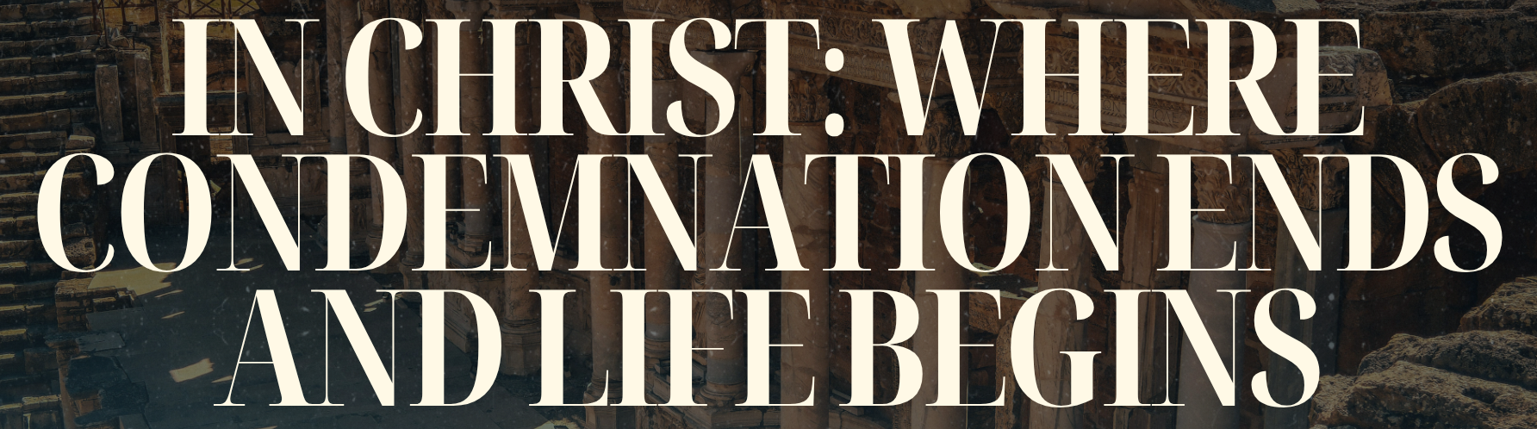
The Bottom Line:

In ______________ ________________, __________________ ends and ____________ begins.

Victory is found by looking outside of ______________ and looking unto ________________.

In Jesus, we have a legal standing of no ___________________________.

In Jesus, you’re free from the law of ______________ and ________________.

The righteous requirement of the law is fulfilled __________ us, not ________ us.

In Christ, we are free to ______________ in the _________________.

Your mind is the arena. You decide who wins the ______________ or the _______________.

In Jesus, you have _________________ and _________________.

In Jesus, we have the ___________________ of _____________________ in us.

What does the Holy Spirit do in you?

1.) The Holy Spirit _________ you to Jesus.
2.) The Spirit puts in you the desire to ______________ Jesus.
3.) The Spirit leads you to be more _________ Jesus.
4.) The spirit stays at _______________ in your ___________.

in Jesus we have the _____________________ of ________________________.

Life Group Questions:

1.) According to verse 1, what does being “in Christ Jesus” immediately change about a believer’s status?
____________________________________________________________________________________________________________________________________________________________________
__________________________________________________________________________________
____________________________________________________________________________________________________________________________________________________________________
__________________________________________________________________________________

2.) Where do you most often feel condemned, and how does Romans 8:1 confront that feeling?
____________________________________________________________________________________________________________________________________________________________________
__________________________________________________________________________________
____________________________________________________________________________________________________________________________________________________________________
__________________________________________________________________________________

3.) What evidence do you see of the “law of the Spirit of life” overpowering the “law of sin and death” in your story?
____________________________________________________________________________________________________________________________________________________________________
__________________________________________________________________________________
____________________________________________________________________________________________________________________________________________________________________
__________________________________________________________________________________

4.) What question wasn’t asked tonight that should have been?
____________________________________________________________________________________________________________________________________________________________________
__________________________________________________________________________________
____________________________________________________________________________________________________________________________________________________________________
__________________________________________________________________________________

Notes:
____________________________________________________________________________________________________________________________________________________________________
____________________________________________________________________________________________________________________________________________________________________
____________________________________________________________________________________________________________________________________________________________________
____________________________________________________________________________________________________________________________________________________________________
__________________________________________________________________________________

