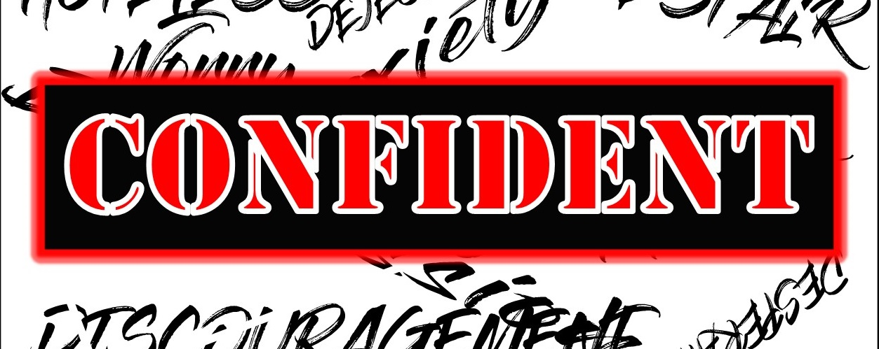
The Bottom Line:
God’s Will For Me,
Is To Be ___________ _______

1. Freedom Is God’s __________

2 Corinthians 3:17 (NLT)
17 For the Lord is the Spirit, and wherever the Spirit of the Lord is, there is freedom.

Authentic _______________ with God leads not to bondage, but to freedom.

It is not _______ _______ that I be caught up in anxiety or depression. His will is freedom and the path to that freedom is in relationship with Him.

Hebrews 11:6 (NKJV)
6 But without faith it is impossible to please Him, for he who comes to God must believe that He is, and that He is a rewarder of those who diligently seek Him.

Two Things To Understand About God

1. ______ _____

2. God Is a __________ _________

Rewarder
Misthapodotēs (Strong’s G3406) (Mis top o dot a’s)
one who pays wages, a rewarder

Apodidōmi (Strong’s G591)
I. To pay off, discharge what is due
Things promised ________ _______

God never speaks a word He does not _________ on __________.

2. Faith Is Freedom’s _____________

Hebrews 11:6(NKJV)
6 But without faith it is impossible to please Him

Faith
Pistis (Strong’s G4102)
Conviction of the ________ of anything

Hebrews 11:1 (NKJV)
1 Now faith is the substance of things hoped for, the evidence of things not seen.

Substance
Hypostasis (Strong’s G5287)
I. A setting or placing under
A. Thing put under, substructure, _____________

Tangible circumstances often __________ faith’s fulfillment.

Faith in the God who is allows us to ______ the promise of _______ and ________ beyond the press of anxiety and depression.

Notes:
________________________________________________________________________________________________________________________________________________________________________________________________________________________________________________________________________________________________________________________________________________________________________________________________________________________________________________________________________________________________________________________________________________________________________________________________________________________________________________________________________________________________________________________________________________________________________________________________________________________________________________________________________________________________________________________________________________________________________________________________________________________________________________________________________________________________________________________________________________________________________________________________________________________________________________________________________________________________________________________________________________________________________________________________________________________________________________________________________________________________________________________________________________________________________________________________________________________________________________________________________________________________________________________________________________________________________________________________________________________________________________________________________________________________________________________________________________

