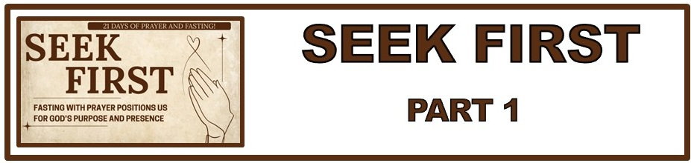
The Bottom Line:
______________ With ______________ Positions Us For God’s Purpose and Presence

1. The “_______”

Matthew 6:16–18 (NKJV)
16 “Moreover, when you fast, do not be like the hypocrites, with a sad countenance. For they disfigure their faces that they may appear to men to be fasting. Assuredly, I say to you, they have their reward. 17 But you, when you fast, anoint your head and wash your face, 18 so that you do not appear to men to be fasting, but to your Father who is in the secret place; and your Father who sees in secret will reward you openly.

Fasting is not only something we _________ do but is something that is a ________ according to Scripture.

2. The “______”

Jesus fasted and taught fasting.

Matthew 4:1–2 (NKJV)
1 Then Jesus was led up by the Spirit into the wilderness to be tempted by the devil. 2 And when He had fasted forty days and forty nights, afterward He was hungry.

It is important to note that it was the time of fasting and prayer that ___________ Jesus for His temptation.

Matthew 9:14–15 (NKJV)
14 Then the disciples of John came to Him, saying, “Why do we and the Pharisees fast often, but
Your disciples do not fast?” 15 And Jesus said to them, “Can the friends of the bridegroom mourn as long
as the bridegroom is with them? But the days will come when the bridegroom will be taken away
from them, and then they will fast.

The Disciples Fasted
Acts 13:2–3 (NKJV)
2 As they ministered to the Lord and fasted, the Holy Spirit said, “Now separate to Me Barnabas and
Saul for the work to which I have called them.” 3 Then, having fasted and prayed, and laid hands
on them, they sent them away.

When the disciples needed the direction of The Holy Spirit, they sought it through __________, _________ and __________.

The Early Church Fasted
Acts 10:30 (NKJV)
30 So Cornelius said, “Four days ago I was fasting until this hour; and at the ninth hour I prayed in my house, and behold, a man stood before me in bright clothing,

It is clear to see that fasting and prayer were a normal part of early Christian ___________ and ____________.

3. The “________”

Biblical fasting is refraining from _______ for a ____________ purpose.
4. The “______”

James 4:10(NKJV)
10Humble yourselves in the sight of the Lord, and He will lift you up.

Fasting is one of the most significant ways scripture gives us for ___________ ourselves before God.

“We cannot transfer that responsibility to God. To pray, “God make me humble is unscriptural because the reply of God in scripture is “Humble Yourself.” - Derek Prince

Suggested foods for Daniel fast
Day 1: Liquids Only

Day 2 through Day 21:
Whole Grains
Brown Rice
Legumes such as: red beans, kidney beans, Black-eyed beans, black beans, Pinto beans
Fruit, Vegetables, Sprouts

Liquids
Water
Soy or Almond Milk
100% vegetable or fruit juice

Foods to avoid:

Meat, poultry, fried foods, soda, preservatives, sugar, caffeine

Life Group Application Questions:

1. What does the prevalence of fasting in the Old and New Testaments tell us about its importance?
________________________________________________________________________________________________________________________________________________________________________________________________________________________________________________________________________________________________________________________________________________

2. What can we learn about the 3-fold chord of giving, praying and fasting in Matthew 6? (Matthew 6:1-18)
___________________________________________________________________________________________________________________________________________________________________________________________________________________________________________________________________________________________________________________________________________________________________________________________________________________________________________

3. How has fasting and prayer benefited you in your life? What are your struggles with fasting and prayer?
________________________________________________________________________________________________________________________________________________________________________________________________________________________________________________________________________________________________________________________________________________
4. What question was not asked here that should have been?
________________________________________________________________________________________________________________________________________________________________________________________________________________________________________________________________________________________________________________________________________________

Notes:
____________________________________________________________________________________________________________________________________________________________________________________________________________________________________________________________

