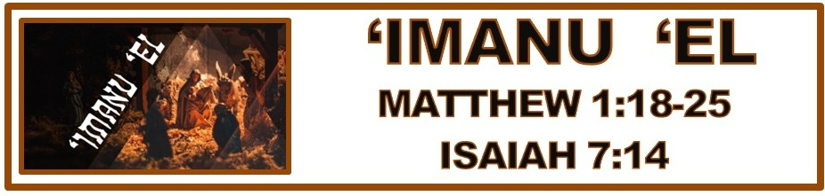
The Bottom Line:
Wherever We Are, God Is ___________ Us!

Matthew 1:18–25 (NKJV)
18 Now the birth of Jesus Christ was as follows: After His mother Mary was betrothed to Joseph, before they came together, she was found with child of the Holy Spirit. 19 Then Joseph her husband, being a just man, and not wanting to make her a public example, was minded to put her away secretly. 20 But while he thought about these things, behold, an angel of the Lord appeared to him in a dream, saying, “Joseph, son of David, do not be afraid to take to you Mary your wife, for that which is conceived in her is of the Holy Spirit. 21 And she will bring forth a Son, and you shall call His name JESUS, for He will save His people from their sins.” 22 So all this was done that it might be fulfilled which was spoken by the Lord through the prophet, saying: 23 “Behold, the virgin shall be with child, and bear a Son, and they shall call His name Immanuel,” which is translated, “God with us.” 24 Then Joseph, being aroused from sleep, did as the angel of the Lord commanded him and took to him his wife, 25 and did not know her till she had brought forth her firstborn Son. And he called His name JESUS.

Isaiah 7:14 (NKJV)
14 Therefore the Lord Himself will give you a sign: Behold, the virgin shall conceive and bear a Son, and shall call His name Immanuel.

I. A _____________ From Sin: (God Who Showed Up)

Jesus (VS 21)
Iēsous (Strong’s G2424)
I. Jehovah is ________________

Jesus was not just any son. He was the ______________ son who entered the world to be its Savior.

We believe That Jesus Christ is the only begotten Son of the Father, conceived of the Holy Ghost, and born of the _____________ Mary.

By ____________ we trust that Jesus, God who stepped out of heaven and became one of us, was born of a virgin, lived a perfect life, died on a cross and rose again. And because He did we can find forgiveness of sin, relationship with God and eternal life.

II. Christmas _______________: (God Is With Us)

Immanuel

‘imanu: ___________ _________

’el: __________

_______________: God Is With Us

Immanuel is not a proper name for Jesus, but a description of His _______________ in every experience of life.

If Christ is present in every experience of life, then I can always trust and ______________ to what He’s saying.

In this next year, wherever ________ am God is with _________!

Notes:
________________________________________________________________________________________________________________________________________________________________________________________________________________________________________________________________________________________________________________________________________________________________________________________________________________________________________________________________________________________________________________________________________________________________________________________________________________________________________________________________________________________________________________________________________________________________________________________________________________________________________________________________________________________________________________________________________________________________________________________________________________________________________________________________________________________________________________________________________________________________________________________________________________________________________________________________________________________________________________________________________________________________________________________________________________________________________________________________________________________________________________________________________________________________________________________________________________________________________________________________________________________________________________________________________________________________________________________________________________________________________________________________________________________________________________________________________________________________________________________________________________________________________________________________________________________________________________________________________________________________________________________________________________________________________________________________________________________________________________________________________________________________________________________________________________________________________________________________________________________________________________________________________________________________________________________________________________________________________________________________________________________________________________________________________________________________________________________________________________________________________________________________________________________________________________________________________________________________________________________________________________________________________________________________________________________________________________________________________________________________________________________________________________________________________________________________________________________________________________________________________________________________________________________________________________________________________________________________________________________________________________________________________________________________________________________________________________________________________________________________________________________________________________________________________________________________________________________________________________________________________________________________________________________________________________________________________________________________________________________________________________________________________________________________________________________________________________________________________________________________________________________________

