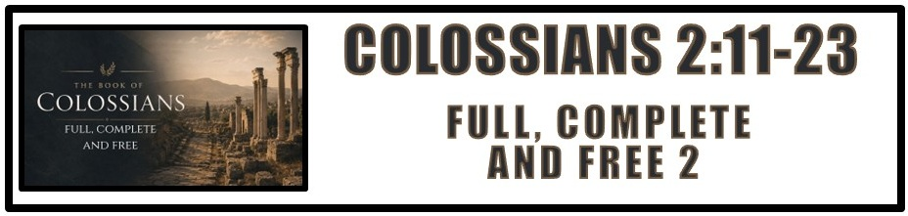
The Bottom Line:
Christ is all in all, and in Him I am ___________, ________________ and ___________.

Baptism is not a sign of righteousness in itself, but an outward symbol of the ______________ ___________of Christ: our death to the old self and resurrection to new life in Him. (VS 12, Romans 6:3-4)

New life in Christ is not gained through human effort but by the ______________ of God. (VS 12)

It is impossible to understand the greatness of the grace of God without understanding the _______________ of death from sin. (VS 13)

The death of sin is inherent in our DNA. Without _____________ there is no hope for life. (VS 13)

___________________ is God joining us to Christ’s victory over sin and death. The same power that raised Christ from the dead has raised us out of the death of sin and into eternal life. (VS 13)

Wiped Out (BDAG) (VS 14)
Wipe away, wipe out, erase, remove, destroy, _________________

Christ carried our __________ and the _________________ due to the cross and gave His life to wipe them away! (VS 14, 2 Corinthians 5:21)

The Foothold of the evil ones is sin. When sin is wiped away by the cross there remains no legal authority. The enemies ______________ have been removed, and their ________________ is stripped away. (VS 15)

All that is part of the Old Testament Law and practice is only a shadow pointing forward to a greater __________________ in ____________. (VS 16-17)

Don’t waste your life chasing shadows when the fulfillment is _________ __________ ___________. (VS 16-17)

Cheat (CDWGTHB) (VS 18)
Defraud, ______________ of reward

True faith does not grow by legalism or through mysticism, it grows through connection with the ___________, Jesus Christ! (VS 19, John 15:1-5, Ephesians 4:11-16)

Those who are in Christ are under no obligation to ____________ ____________ religion or action. (VS 20-21)

Only through Christ, the head, can we ___________ in relationship with God and overcome the sins and weaknesses of our flesh. (VS 22-23)
Notes:
________________________________________________________________________________________________________________________________________________________________________________________________________________________________________________________________________________________________________________________________________________________________________________________________________________________________________________________________________________________________________________________________________________________________________________________________________________________________________________________________________________________________________________________________________________________________________________________________________________________________________________________________________________________________________________________________________________________________________________________________________________________________________________________________________________________________________________________________________________________________________________________________________________________________________________________________________________________________________________________________________________________________________________________________________________________________________________________________________________________________________________________________________________________________________________________________________________________________________________________________________________________________________________________________________________________________________________________________________________________________________________________________________________________________________________________________________________________________________________________________________________________________________________________________________________________________________________________________________________________________________________________________________________________________________________________________________________________________________________________________________________________________________________________________________________________________________________________________________________________________________________________________________________________________________________________________________________________________________________________________________________________________________________________________________________________________________________________________________________________________________________________________________________________________________________________________________________________________________________________________________________________________________________________________________________________________________________________________________________________________________________________________________________________________________________________________________________________________________________________________________________________________________________________________________________________________________________________________________________________________________________________________________________________________________________________________________________________________________________________________________________________________________________________________________________________________________________________________________________________________________________________________________________________________________________________________________________________________________________________________________________________________________________________________________________________________________________________________________________________________________________________________________________________________________________________________________________________________________________________________________________________________________________________________________________________________________________________________________________________________________________________________________________________________________________________________________________________________________________________________________________________________________________________________________________________________________________________________________________________________________________________________________________________________

