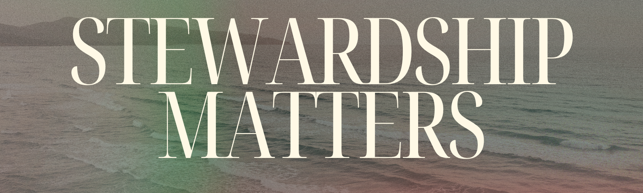
Bottom Line:
_______________ isn’t what you earn, but how you use what’s been entrusted.

If God put a lot in your hands, He wants you to be _________________ and help others.

God will reward you ___________________ for your faithfulness ____________________.

God’s heart is a ______________ heart, a ________________ heart, and a ________________ heart.

4 aspects of ownership thinking

1.) I do ________ belong to the Lord.
2.) Nothing I _____________ belongs to the Lord.
3.) I _________________ all that I work for.
4.) I only answer to _______________.

4 principles of stewardship

1.) I ________________ to the Lord
2.) Everything I _______________ belongs to the Lord.
3.) Everything I have is a ______________.
4.) I am a _______________ of the Lord.

If God is ____________________ with us, we want to be ________________ with others.

Application Questions

1.) In what practical ways can you evaluate whether your daily decisions about time, money, or talents reflect stewardship of what God has entrusted rather than ownership of what you’ve earned?__________________________________________________________________________________________________________________________________________________________________________________________________________________________________________________________________________________________________________________________________________________________________________________

2.) James warns the rich about their wealth rotting and corroding as evidence against them. How does the truth that "God will reward you eternally for your faithfulness presently" challenge the mindset of accumulating wealth for selfish gain rather than sharing it generously?________________________________________________________________________________________________________________________________________________________________________________________________________________________________________________________________________________________________________________________________________________

3.) How do the differing mindsets of stewardship and ownership affect the church?________________________________________________________________________________________________________________________________________________________________________________________________________________________________________________________________________________________________________________________________________________

4. What stood out to you most from Sundays message & what question wasn’t asked that should have been?
________________________________________________________________________________________________________________________________________________________________________________________________________________________________________________________________________________________________________________________________________________

Notes:
________________________________________________________________________________________________________________________________________________________________________________________________________________________________________________________________________________________________________________________________________________________________________________________________________________________________________________________________________________________________________________________________________________________________________________________________________________________________________________________________________________
________________________________________________________________________________________________________________________________________________________________________________________________________________________________________________________________________________________________________________________________________

