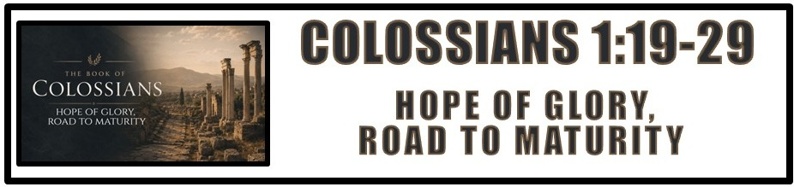
The Bottom Line:
Christ In Me, The Hope of ____________ and Road to _______________

Fullness
______________ (EDNT)
Fullness, fulfillment

In Jesus Christ, the fullness of God, every attribute and perfection of divine nature, dwells ________________ and _________________ in bodily form. (VS 19)

Jesus Christ is __________! (VS 19)

Ultimately, all things in heaven and on earth will be _________________ and brought under the rulership of Christ. When this occurs Christ will then present this kingdom to His Father and they will rule and reign in perfection forever. (VS 20, 1 Corinthians 15:20-28)

The Gentile ___________ Of _________________: (VS 21-22, Ephesians 2:12-13)

1. Without Christ

2. Rejected from citizenship

3. No covenant relationship with God

4. Without God

5. No hope

All who are without _____________ find themselves separated from God, hopeless and in need of a savior. (VS 21-22)

The blood of Christ changes _________________. Those lost and without hope are found and brought home. (VS 21-22)

Those who place their trust in the ____________ of Christ are made: (VS 21-22)

1. Reconciled: Restored to favorable relationship with God, The Father

2. Holy: Set apart in purity for the purposes of God

3. Blameless: Without spot, wrinkle or defect

4. Above Reproach: Unaccusable, irreproachable, completely cleared of guilt

Two views of “continuing in faith.” (VS 23)

1. To move away from faith causes the ___________ of salvation and relationship with God

2. The “perseverance of the saints” means one who is truly saved will ___________ move away from faith.
The blessings of the gospel only remain for those who _______________ in the gospel. (VS 23)

The mysteries of God are those things which were hidden or not fully known in the Old Testament but have been _______________ through the ministry of Christ and the revelation of the Holy Spirit. (VS 25-26)

The mystery revealed is that _________ _____________, God has reconciled Jews and Gentiles into one new church, with Christ living in them as the hope of glory. This is the present reality of God’s kingdom, which will reach its full completion at the return of Christ. (VS 27)

_______________ _______________ warns against what harms and equips with what perfects, so that each believer may be presented mature in Christ. This is not by our work alone, but by God’s powerful work within us. (VS 28-29)

Notes:
________________________________________________________________________________________________________________________________________________________________________________________________________________________________________________________________________________________________________________________________________________________________________________________________________________________________________________________________________________________________________________________________________________________________________________________________________________________________________________________________________________________________________________________________________________________________________________________________________________________________________________________________________________________________________________________________________________________________________________________________________________________________________________________________________________________________________________________________________________________________________________________________________________________________________________________________________________________________________________________________________________________________________________________________________________________________________________________________________________________________________________________________________________________________________________________________________________________________________________________________________________________________________________________________________________________________________________________________________________________________________________________________________________________________________________________________________________________________________________________________________________________________________________________________________________________________________________________________________________________________________________________________________________________________________________________________________________________________________________________________________________________________________________________________________________________________________________________________________________________________________________________________________________________________________________________________________________________________________________________________________________________________________________________________________________________________________________________________________________________________________________________________________________________________________________________________________________________________________________________________________________________________________________________________________________________________________________________________________________________________________________________________________________________________________________________________________________________________________________________________________________________________________________________________________________________________________________________________________________________________

