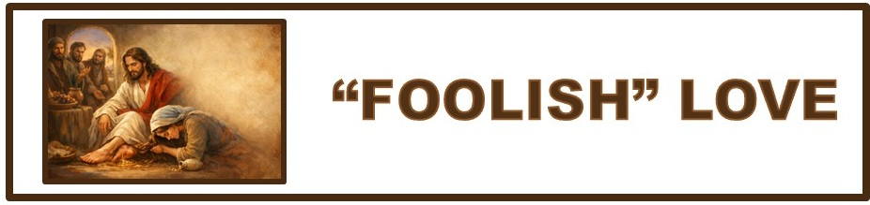
The Bottom Line:
______________ ___________ Poured On Us
Merits The “Foolishness” Of Devotion Poured On Him!

John 12:1–8 (NKJV)
1 Then, six days before the Passover, Jesus came to Bethany, where Lazarus was who had been dead, whom He had raised from the dead. 2 There they made Him a supper; and Martha served, but Lazarus was one of those who sat at the table with Him. 3 Then Mary took a pound of very costly oil of spikenard, anointed the feet of Jesus, and wiped His feet with her hair. And the house was filled with the fragrance of the oil. 4 But one of His disciples, Judas Iscariot, Simon’s son, who would betray Him, said, 5 “Why was this fragrant oil not sold for three hundred denarii and given to the poor?” 6 This he said, not that he cared for the poor, but because he was a thief, and had the money box; and he used to take what was put in it. 7 But Jesus said, “Let her alone; she has kept this for the day of My burial. 8 For the poor you have with you always, but Me you do not have always.”

1. The ___________ Of Christ’s Death Merits The “Foolishness” Of Love! (VS 7)

If you wait until the memorial to say I love you, it’s __________ ___________.

In a world of self-centered calculation, extravagant devotion is reckoned as ___________________.

2. True Prophetic Insight Flows From Pure __________________ _______________

Mary’s act wasn’t simply an act of kindness; it was a ________________ declaration!

Mary understood the purpose and plan of God because she consistently spent ______________ ___________ with Jesus.

The fragrance of Mary’s oil meant to cover the stench of death, ultimately became the ____________ of ______________.

When we pour out our time, talents, treasure, or testimony on Jesus, not for convenience, but for His worth, we declare what Mary did: death loses. Jesus lives, and He is _____________ of it all.

In a culture obsessed with “what’s in it for me”, extravagant worship is an act of _______________. It speaks resurrection when all of life looks like death.

3. _____________ In Your Jar?

Life is always full of need, pressure and responsibility. The question in the middle of it all is what I do with the message of the crucified and risen Savior who is ___________ me __________.

Those who pour out their lives for Christ, do not sacrifice for a dead teacher or a good moral example. They pour out their lives for the __________________, ___________ _____________ King of kings and Lord of Lords.

Sin ________________, Christ _______________
Notes:
______________________________________________________________________________________________________________________________________________________________________________________________________________________________________________________________________________________________________________________________________________________________________________________________________________________________________________________________________________________________________________________________________________________________________________________________________________________________________________________________________________________________________________________________________________________________________________________________________________________________________________________________________________________________________________________________________________________________________________________________________________________________________________________________________________________________________________________________________________________________________________________________________________________________________________________________________________________________________________________________________________________________________________________________________________________________________________________________________________________________________________________________________________________________________________________________________________________________________________________________________________________________________________________________________________________________________________________________________________________
____________________________________________________________________________________________________________________________________________________________________________________________________________________________________________________________________________________________________________________________________________________________________________________________________________________________________________________________________________________________________________________________________________________________________________________________________________________________________________________________________________________________________________________________________________________________________________________________________________________________________________________________________________________________________________________________________________________________________________________________________________________________________________________________________________________________________________________________________________________________________________________________________________________________________________________________________________________________________________________________________________________________________________________________________________________________________________________________________________________________________________________________________________________________________________________________________________________________________________________________________________________________________________________________________________________________________________________________________________________________________________________________________________________________________________________________________________________________________________________________________________________________________________________________________________________________________________________________________________________________________________________________________________________________________________

