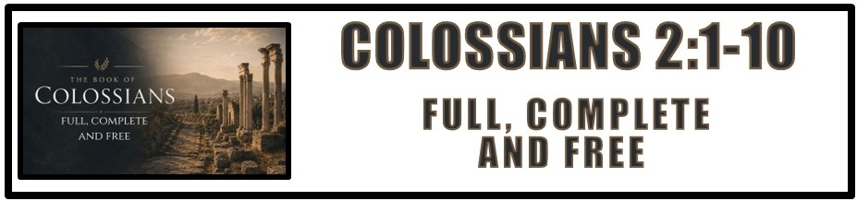
The Bottom Line:
Christ is all in all, and in Him I am ____________, _______________ and ____________.

Paul’s conflict was not against flesh and blood, but of ____________ and __________________. (VS 1, 2 Corinthians 10:3-6)

God is our ultimate _________________, but how does He do that? (VS 2)

1. Prayer: Paul through his prayer and our prayer for one another

2. Love: The maturing love of each believer one for another.

3. The Word of God: The maturing of faith and understanding in the Word of God.

Everything we need is to be found in ___________________ with and a deeper ____________________ of The Father, The Son and The Holy Spirit. (VS 2-3)

Deceive (VS 4)
Paralogizomai
Deceive, _____________, reckon fraudulently, Defraud

The best ______________ against what is false, is a strong and growing knowledge of what is true. (VS 2-5)

Get in the Word, Grow in the Word, ___________ the _____________! (VS 4-5)

Rooted (VS 7)
Rhizoō (BDAG)
Be/Become firmly rooted or fixed

Perfect Tense: Indicates an action which is viewed as having been ________________ in the past, once and for all, not needing to be repeated.

Passive Voice: Indicates the subject _______________ the action rather than doing it.

Built up (VS 7)
Epoikodomeō (BDAG)
Build on to; edify, build up/on

Present Tense: Indicates a simple statement of fact or reality viewed as occurring in actual time. In most cases this corresponds directly with the English ______________ tense.

Passive Voice: Indicates the subject receives the action rather than doing it.

Established (VS 7)
Bebaioō (BDAG)
Confirm, establish, strengthen

Present Tense: Indicates a simple statement of fact or reality viewed as occurring in actual time. In most cases this corresponds directly with the English present tense.

Passive Voice: Indicates the subject receives the action rather than doing it.

Abounding (VS 7)
Perisseuō (BDAG)
Abound, cause to abound

Present Tense: Indicates a simple statement of fact or reality viewed as occurring in actual time. In most cases this corresponds directly with the English present tense.

Active Voice: Indicates the ______________ as the ___________ or performer of the action.

Four ____________ of false teaching: (VS 8)

1. Philosophy: Literally “the philosophy.” Refers to the mixed beliefs of the “Colossian heresy.”

2. Empty Deceit: False teaching that seems impressive but has nothing real inside. Promises spiritual growth or deeper knowledge, but it’s nothing but babble.

3. Tradition of men: Likely a reference to the Jewish rabbinic traditions that “interpreted” the law of Moses. Eventually the law became irrelevant and unfollowable due to the burden of traditions. (Mark 7:8-9)

4. Principles of the world: false teaching that emphasizes the need for “special rules.” And religious rituals in order to truly be spiritual. Or more likely the worship of demonic spiritual powers (fallen angelic rulers, demons) instead of holding fast to Christ. (VS 15, 18, 20)

Faithful believers must realize that all they need is in _____________ and His ___________. (VS 8)

Godhead (VS 9)
Theotēs (BDAG)
Divine character/_____________, deity, divinity

Strong’s concordance: The state of being God,

Complete (VS 10)
Peplērōmenoi (BDAG)
To be _____________ full, filled up, _______________, finished

Three truths for the _______________ in Christ: (VS 9-10)

1. Full: We are filled with Christ

2. Complete: We are complete in Christ

3. Free: There is no power we must respond to higher than Christ.

Notes:
____________________________________________________________________________________________________________________________________________________________________________________________________________________________________________________________________________________________________________________________________________________________________________________________________________________________________________________________________________________________________________________________________________________________________________________________________________________________________________________________________________________________________________________________________________________________________________________________________________________________________________________________________________________________________________________________________________________________________________________________________________________________________________________________________________________________________________________________________________________________________________________________________________________________________________________________________________________________________________

