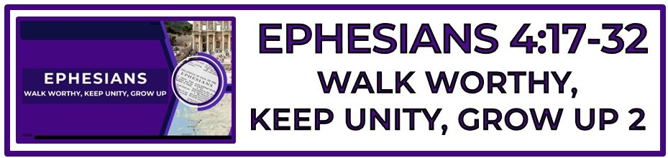
The Bottom Line:
To Know Who I Am In Christ Allows Me To ___________ As I Should In Christ.

____________, _______________ and _______________ are three primary marks of an authentic Christian walk of faith. (VS 17-18)

Since _____________ has made a way for us to be a part of the Kingdom of God, (2:11-13) we should not walk as we once did in futility of mind as other gentiles. (VS 17-18)

Futility (VS 17)
Mataiotēs (Strong’s G3153)
I. devoid of force, truth, success, result
II. useless, of _________ ______________

Spiritual blindness leads to a _______________ mind, spirit and life. (Romans 1:21, 2 Corinthians 4:4)

The more you live in _________________ to God’s purpose, the darker your life becomes. (VS 17-18)

How do we become _______________ in Spirit and new in life: (VS 20-24)

1. Learn about relationship with Jesus Christ. (John 14:6, Philippians 3:10)

2. Offer yourself completely to God. (Romans 12:1-2, 1 Corinthians 6:19-20)

3. Submit yourself completely to the truth of the Word of God. (Psalm 119:9, 11, 2 Corinthians 10:3-6, Ephesians 5:25-27)

4. Pray and trust God continually. (Proverbs 3:5-6)

The truly godly will work, live and sacrifice to live a life of _______________ _________________ to the best of their ability. (VS 28)

Corrupt (VS 29)
Sapros (Strong’s G4550)
I. _____________, putrefied
II. corrupted by one and no longer fit for use, worn out
III. of poor quality, bad, unfit for use, worthless

Our words reveal more than syllables spoken, they uncover a heart ___________ ___________. (VS 29-30, Luke 6:45)

Our response to others should be _______________ according to Christ’s response of grace to us.

Life Group Application Questions:

1. Are there areas of my life where I default to a “gentile” mindset when I’m stressed, tired, challenged or under pressure. (Bitterness, anger, lust, selfishness, compromise, etc) (VS 17)
________________________________________________________________________________________________________________________________________________________________________________________________________________________________________________________________________________________________________________________________________________

2. How should our view of generosity affect our attitude toward work, service and giving. (VS 28)
____________________________________________________________________________________________________________________________________________________________________________________________________________________________________________________________________________________________________________________________________________________________________________________________________

3. On a scale of 1-10 (1-Not Aware 10-Very aware) How aware am I of how my words and attitude work to build up or tear down those around me. (Family, friends, Church family, Co-workers, etc.) What does this reveal to me about the words I choose to speak?
________________________________________________________________________________________________________________________________________________________________________________________________________________________________________________________________________________________________________________________________________________
4. What question was not asked here that should have been?
____________________________________________________________________________________________________________________________________________________________________________________________________________________________________________________________________________________________________________________________________________________________________________________________________________________________________

Notes:
________________________________________________________________________________________________________________________________________________________________________________________________________________________________________________________________________________________________________________________________________________________________________________________________________________________________________________________________________________________________________________________________________________________________________________________________________________________________________________________________________________________________________________________________________________________________________________________________________________________________________________________________________________________________________________________________________________________________________________________________________________________________________________________________________________________________________________________________________________________________________________________________________________________________________________________________________________________________________________________________________________________________________________________________________________________________________________________________________________________________________________________________________________________________________________________________________________________________________________________________________________________________________________________________________________________________________________________________________________________________________________________________________________________________________________________________________________________________________________________________________________________________________________________________________________________________

