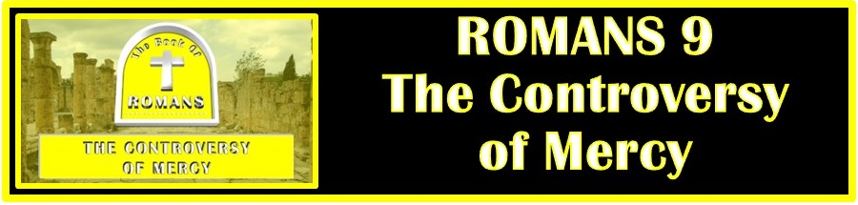
The Bottom Line:
God’s mercy is _______________ to the humble who ____________

Sovereignty: That God has the power, wisdom, and _______________ to do anything He chooses within His creation.

1. God’s ____________ of Mercy

The Jews were chosen by God to be the conduit of God’s redemption in two ways:

1. Through the revelation of the __________

2. To be the people from which ______________ would come to fulfill the law and bring salvation to both Jew and Gentile.

Passion for the lost is born in an atmosphere of _____________.

All
Pas (Strong’s G3956)
I. individually
A. each, every, any, all, the whole, everyone, all things, _________________

2. The __________________ of Mercy

Three examples of God’s sovereignty in choosing whom He will use for His purpose:

1. ____________ and Ishmael (Vs 7-9)

2. ____________ and Esau (Vs 10-13)

3. _______________ (Vs 14-18)

If God is sovereign, He’s under no _________________ to show mercy and grace to anyone.

That God would act with mercy and grace toward anyone is a reflection of the greatness of His ____________. (2 Corinthians 3:7-4:1)

God has revealed to whom He, in His sovereignty, chooses to show mercy to. To those who will _____________ _________________. (James 4:7-10)

Salvation is not attained by work you do, but ________________ what you cannot do.
Life Group Application Questions

1. In what way is passion for the lost born in an atmosphere of prayer. (Vs 1-5, Romans 10:1)
________________________________________________________________________________________________________________________________________________________________________________________________________________________________________________________________________________________________________________________________________________________________________________________

2. What is the sovereignty of God? How is God’s sovereignty reflected in His choice of Isaac and Jacob?
(Vs 6-13)
________________________________________________________________________________________________________________________________________________________________________________________________________________________________________________________________________________________________________________________________________________

3. How does the mercy of God reveal the greatness of His glory? (1 Corinthians 3:7-4:1)
________________________________________________________________________________________________________________________________________________________________________________________________________________________________________________________________________________________________________________________________________________

4. To whom does God choose to show His mercy? (James 4:7-10, See also Romans 10:9-13, John 3:16
1 John 1:9) Does the answer to this question reflect a work which qualifies an individual for salvation?
________________________________________________________________________________________________________________________________________________________________________________________________________________________________________________________________________________________________________________________________________________

5 What are you going to do with what you learned in this chapter?
________________________________________________________________________________________________________________________________________________________________________________________________________________________________________________________________________________________________________________________________________________________________________________________________________

Notes:
__________________________________________________________________________________________________________________________________________________________________________________________________________________________________________________________________________________________________________________________________________________________________________________________________________________________________________________________________________________________________________________________________________________________________________________________________________________________________________________________________________________________________________________________________________________________________________________________________________________________________________________________________________________________________________________________________________________________________________________________________________________________________________________________________________________________________________________________________________________________________________________________________________________________________________________________________________________________________________________________________________________________________________________________________________________________________________________

