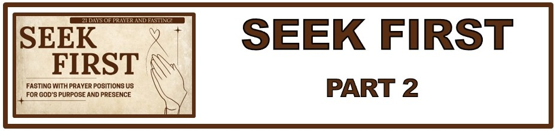
The Bottom Line:
______________ With ______________ Positions Us For God’s Purpose and Presence

Matthew 6:16–18 (NKJV)
16 “Moreover, when you fast, do not be like the hypocrites, with a sad countenance. For they disfigure their faces that they may appear to men to be fasting. Assuredly, I say to you, they have their reward. 17 But you, when you fast, anoint your head and wash your face, 18 so that you do not appear to men to be fasting, but to your Father who is in the secret place; and your Father who sees in secret will reward you openly.

The When, Who, What and Why Of Fasting and Prayer:

1. The When: Regular fasting with prayer is _____________ Christian discipline.

2. The Who: Jesus, Disciples, Early church all practiced fasting

3. The What: Fast: Refraining from food for a ________________ purpose

4. The Why: To _____________ ourselves before God and say you are our source, wisdom and provision.

1. The _____________ Walk

Acts 1:8(NKJV)
8“But you shall receive power when the Holy Spirit has come upon you; and you shall be witnesses to Me in Jerusalem, and in all Judea and Samaria, and to the end of the earth.”

The ____________ we must have to live an effective Christian life and to advance the message of God’s kingdom is in the ___________ _____________ alone.

2. The Serious ______________

Galatians 5:16–17 (NKJV)
16 I say then: Walk in the Spirit, and you shall not fulfill the lust of the flesh. 17 For the flesh lusts against the Spirit, and the Spirit against the flesh; and these are contrary to one another, so that you do not do the things that you wish.

Fasting is a powerful means of putting __________ our old sinful nature and putting _________ new life in the Spirit. (Ephesians 4:22)

Ephesians 4:22 (NKJV)
22 that you put off, concerning your former conduct, the old man which grows corrupt according to the deceitful lusts,

Fasting Is A ____________ _____________
3. A ____________ In Thinking

Joel 2:12 (NLT)
12 That is why the LORD says, “Turn to me now, while there is time. Give me your hearts. Come with fasting, weeping, and mourning.

Three admonitions from Joel 2:12 (New Living Translation)

1. ___________ to God and away from selfish and fleshly pursuits.

2. ___________: Give all of your mind, will, emotions and life to pursue Christ and His purpose.

3. ___________: Come with fasting and prayer, seeking God above all else

Joel 2:13 (NLT)
13 Don’t tear your clothing in your grief, but tear your hearts instead.” Return to the LORD your God, for he is merciful and compassionate, slow to get angry and filled with unfailing love. He is eager to relent and not punish.


A Willing _______________ Brings A Wave Of ______________.

Life Group Application Questions:

1. Describe in your own words the battle between our spirit and our flesh. (Acts 1:8, Galatians 5:16-17)
________________________________________________________________________________________________________________________________________________________________________________________________________________________________________________________________________________________________________________________________________________

2. How does fasting/prayer help in putting off our flesh and putting on life in The Spirit. (Ephesians 4:22)
___________________________________________________________________________________________________________________________________________________________________________________________________________________________________________________________________________________________________________________________________________________________________________________________________________________________________________

3. How does our willing response to God’s call to repentance position us for a wave of blessing? (Joel 2:12-13 <<Note this in New Living Translation, Matthew 6:18)
________________________________________________________________________________________________________________________________________________________________________________________________________________________________________________________________________________________________________________________________________________
4. What question was not asked here that should have been?
________________________________________________________________________________________________________________________________________________________________________________________________________________________________________________________________________________________________________________________________________________

Notes:
________________________________________________________________________________________________________________________________________________________________________________________________________________________________________________________________________________________________________________________________________________________________________________________________________________________________________________________________________________________________________________________________________________________________________________________________________________________________________________________________________________________________

