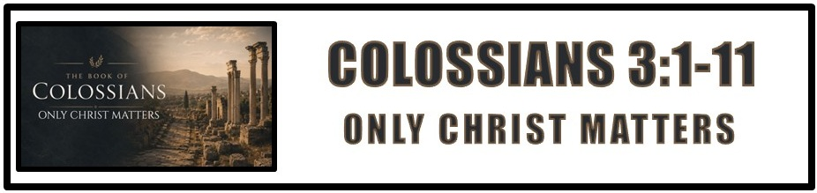
The Bottom Line:
Only Christ Matters, And Christ Is _________ _________!

You were _____________ (BDAG) (VS 1)
Awaken With, Raise with

Aorist tense, Passive Voice: Like a snapshot of something that happened. It isn’t happening, It isn’t going to happen, it happened. It’s a done deal. The passive voice reflects something that happens to someone.

___________ (BDAG) (VS 1)
Look for, investigate, examine, strive for

Present tense, Active voice, Imperative mood: Always actively engaged in seeking. Imperative mood reflects a command or an exhortation.

Three attributes of “above.” (VS 1-2)

1. It’s where _____________ is. We live now for what is to come. One day we will be with Christ in Heaven. (VS 3-4)

2. Christ is ______________: There were no chairs in O.T. tabernacle. Priests didn’t sit because their duties were perpetual, always repeatedly offering sacrifice for sin. Christ sits in the heavenly tabernacle because His one-time sacrifice was enough. (Hebrews 1:3, 10:12)

3. Christ’s _______________: Christ is not only seated but He is seated at the right hand of God. This is the place of honor, authority and power. Christ is not fighting for authority, He is reigning in authority.

Those who have been raised with Christ have a _____________________ and ______________ to seek the things of heaven above and not earth below. (VS 1-2)

The moment we trust in Christ, we die to __________ and our __________ ___________. This is what is represented in our baptism. (VS 3-4, Romans 6:3-8, Colossians 2:11-13)

Life in Christ is both __________ and __________ __________. Our salvation, life and identity are secure in Christ now, but the fullness of salvation and glorification is still to come when we appear with Him in glory. (VS 3-4)

Through Christ, sin and flesh have been killed. We must live our lives accordingly, eliminating all ________________ _____________ _______________. (VS 5-6)

Am I ____________ ___________ to say, “Thank God that, in Christ, I no longer look or live as I once did? (VS 7)

Put off the old man and ____________ will lose its place in your life. (VS 8-9)

True renewal in Christ is not just putting off the old self, it is putting on the new self, which is being ______________ in the image of its Creator. (VS 10, Romans 12:1-2, 2 Corinthians 4:16, Ephesians 4:23)

To know Christ is to grow in Christ. This is renewal into __________ ____________. (VS 10)

Every believer has only one ultimate identity, “_________ _____________.” All other dividing factors fade in the light of the glory of the family of God. (VS 11)

Notes:
____________________________________________________________________________________________________________________________________________________________________________________________________________________________________________________________________________________________________________________________________________________________________________________________________________________________________________________________________________________________________________________________________________________________________________________________________________________________________________________________________________________________________________________________________________________________________________________________________________________________________________________________________________________________________________________________________________________________________________________________________________________________________________________________________________________________________________________________________________________________________________________________________________________________________________________________________________________________________________________________________________________________________________________________________________________________________________________________________________________________________________________________________________________________________________________________________________________________________________________________________________________________________________________________________________________________________________________________________________________________________________________________________________________________________________________________________________________________________________________________________________________________________________________________________________________________________________________________________________________________________________________________________________________________________________________________________________________________________________________________________________________________________________________________________________________________________________________________________________________________________________________________________________________________________________________________________________________________________________________________________________________________________________________________________________________________________________________________________________________________________________________________________________________________________________________________________________________________________________________________________________________________________________________________________________________________________________________________________________________________________________________________________________________________________________________________________________________________________________________________________________________________________________________________________________________________________________________________________________________________________________________________________________________________________________________________________________________________________________________________________________________________________________________________________________________________________________________________________________________________________________________________________________________________________________________________________

