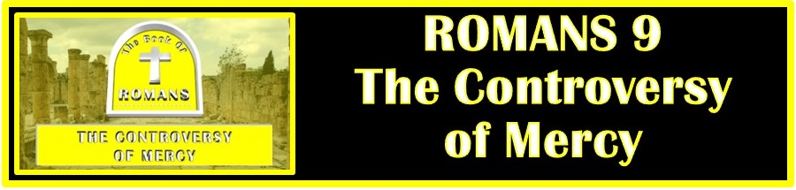
The Bottom Line:
God’s mercy is _______________ to the humble who ____________

Sovereignty: That God has the power, wisdom, and _______________ to do anything He chooses within His creation.

1. Vessels of ____________

Two Arguments regarding God’s dealing with Pharaoh:

1. God arbitrarily ___________ Pharaoh hard hearted.

2. God used who Pharaoh had ______________ _____________ to be to accomplish His purpose in freeing the Israelites.

2 Timothy 2:20–21 (NKJV)
20 But in a great house there are not only vessels of gold and silver, but also of wood and clay, some for honor and some for dishonor. 21 Therefore if anyone cleanses himself from the latter, he will be a vessel for honor, sanctified and useful for the Master, prepared for every good work.

Those “prepared for destruction” were prepared, not by divine predetermination but by damnable _______________.

God’s just judgment comes only to those to whom God has shown _______________ _______________.

2. Vessels of ____________

What has God done to prepare believers for His glory?

1. Through the death and resurrection of Christ, we have been forgiven of sin and raised to __________ ___________.

2. Through faith we are __________________ into the image of Christ, preparing us for eternity with God.

Those who come to Christ by ____________ will be transformed from a “vessel of wrath” to a “vessel of mercy.”

Those, whether Jew or Gentile, who pursue righteousness by “____________ of the law” will never attain righteousness.

Life Group Application Questions

1. Read Romans 9:17: Was Pharaoh heart hardened before or after God spoke these words? (See Exodus 7:14, 9:16)
____________________________________________________________________________________________________________________________________________________________________________________________

2. How does Paul’s discussion of Pharaoh give insight into God’s dealings with Israel? (Vs 17-18)
________________________________________________________________________________________________________________________________________________________________________

3. What role does God’s abundant patience play in determining the timing of His judgments? (Vs 22)
________________________________________________________________________________________________________________________________________________________________________________________________________________________________________________________________________________________________________________________________________________

4. Does Israel’s rebellion against God mean God has broken His promise to the Jews? Explain? (Vs 25-33)
________________________________________________________________________________________________________________________________________________________________________________________________________________________________________________________________________________________________________________________________________________

5. What role does faith play in the transformation from “vessel of wrath” to “vessel of mercy? (23-24, 30-33)
________________________________________________________________________________________________________________________________________________________________________________________________________________________________________________________________________________________________________________________________________________

6. What are you going to do with what you learned in this chapter?
________________________________________________________________________________________________________________________________________________________________________________________________________________________________________________________________________________________________________________________________________________________________________________________________________

Notes:
______________________________________________________________________________________________________________________________________________________________________________________________________________________________________________________________________________________________________________________________________________________________________________________________________________________________________________________________________________________________________________________________________________________________________________________________________________________________________________________________________________________________________________________________________________________________________________________________________________________________________________________________________________________________________________________________________________________________________________________________________________________________________________________________________________________________________________________________________________________________________________________________________________________________________________________________________________

