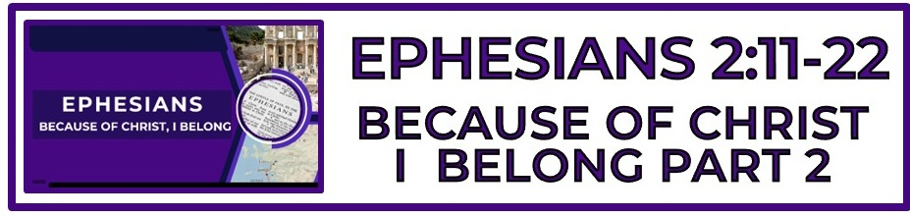

The Bottom Line:
I Will Never Forget, Because Of Christ, I _____________

The Gentile ___________ Of _________________: (VS 12)

1. Without Christ
2. Rejected from citizenship
3. No covenant relationship with God
4. Without God
5. No hope

All who are without ___________ find themselves behind a wall of separation from God, hopeless and in need of a savior. (VS 12)

The blood of Christ changes _________________. Those lost and without hope are found and brought home. (VS 13)

Enmity (VS 15-16)
Echthra (Strong’s G2189)
To be ______________ or ______________ opposed.

In Christ we are no longer separated by ethnicity, social status, economics or any other human division. We are all made into “__________ __________ __________” born from above. (VS 15-16)

The message of peace in Christ is advanced by Christ through ________________ who carry His hope into a hostile and divided world. (VS 17)

Not only is the wall of separation between believers removed in Christ, but the wall of separation from __________ _____________ has also been removed. (VS 17, Romans 5:2, Ephesians 3:12, Hebrews 4:14-16)

Because of the cross of Christ, we have access to The Father through The ___________ _____________. (VS 17, John 15:26-27, 16:7-15, Acts 1:8)

We were cut off from God’s people, God’s covenant, and God Himself. We did not belong. But now we _____________ to an eternal family being built into an eternal kingdom. (VS 19)

Sometimes the chaos of life on earth distracts us from our only _______________ ______________: to lead others to Christ. (VS 19)

From the apostles and prophets through time until _________, it is imperative that the family of God be lined up with the cornerstone, Jesus Christ. (VS 20-21)

God has been and is placing specific individuals into His house for His purpose in order to become a unified temple which houses the _______________ of the Holy Spirit. (VS 22, Ephesians 4:11-12, 1 Peter 2:4-5)
Notes:
________________________________________________________________________________________________________________________________________________________________________________________________________________________________________________________________________________________________________________________________________________________________________________________________________________________________________________________________________________________________________________________________________________________________________________________________________________________________________________________________________________________________________________________________________________________________________________________________________________________________________________________________________________________________________________________________________________________________________________________________________________________________________________________________________________________________________________________________________________________________________________________________________________________________________________________________________________________________________________________________________________________________________________________________________________________________________________________________________________________________________________________________________________________________________________________________________________________________________________________________________________________________________________________________________________________________________________________________________________________________________________________________________________________________________________________________________________________________________________________________________________________________________________________________________________________________________________________________________________________________________________________________________________________________________________________________________________________________________________________________________________________________________________________________________________________________________________________________________________________________________________________________________________________________________________________________________________________________________________________________________________________________________________________________________________________________________________________________________________________________________________________________________________________________________________________________________________________________________________________________________________________________________________________________________________________________________________________________________________________________________________________________________________________________________________________________________________________________________________________________________________________________________________________________________________________________________________________________________________________________________________________________________________________________________________________________________________________________________________________________________________________________________________________________________________________________________________________________________________________________________________________________________________________________________________________________________________________________________________________________________________________________________________________________________________________________________________________________________________________________________________________________________________________________________________________________________________________________________________________________________________________________________________________________________________________________________________________________________________________________________________________________________________________________________________________________________________________________________________________________________________________________________________________________________________________________________________________________________________________________________________________________________________________________________________________________________________________________________________________________________________________________________________________________________________________________________________________________________________________________________________________________________________________________________________________________________________________________________________________________________________________________________________________________________________________________________________________________________________________________________________________________________________________________________________________________________________________________________________________________________________________________________________

