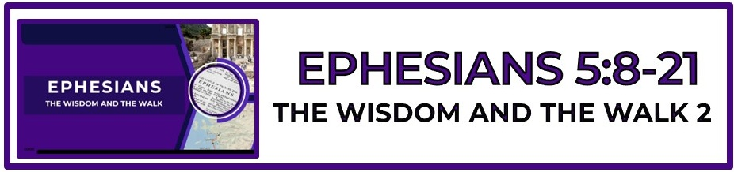

The Bottom Line:
Those Who Are _________ Christ Will, In Love And Holiness, ______________ Christ.

What is the ____________ in which we walk in the LORD? (VS 8)

1. Glory: God’s physical glory is often presented in the language of light. (Exodus 13:21-22, 24:17, Psalm 104:1-2, Isaiah 60:1-2, Ezekiel 1:27-28)

2. Holiness: God’s moral character is described in the language of light. (1 John 1:5)

3. Omniscience: God’s knowledge is described in language of light. (Daniel 2:22, Psalm 139:11-12, Hebrews 4:13,)

Those who are made new _________ _____________ have become children of light and must no longer choose to live in darkness. (VS 8, Matthew 5:14-16, John 3:21, 8:12, Romans 13:12, 1 Thessalonians 5:4-5)

Characteristics of ____________-______________: (VS 9-10)

1. Goodness: To be upright in heart and life, kindness

2. Righteousness: integrity, virtue, purity of life, rightness, correctness of thinking feeling, and acting

3. Truth: Truth in things pertaining to God, the duties of man, moral and religious truth. (Conformity to the Word of God)

God’s acceptable will for our lives is revealed in the acceptable ________________ of ourselves completely to His Word and way. (VS 9-10, Romans 12:1-2)

God reveals Himself _____________ to those who walk with Him __________________. (VS 9-10)

Fellowship (VS 11)
Stygkoinōneō (Strong’s G4790)
to become a partaker _______________ ___________ others, or to have fellowship with a thing

Light expels darkness when church leadership and church body are ________________ and ________________ to the Word of God and the leading of the Holy Spirit. (VS 11, Ephesians 4:11-16, 2 Timothy 3:16-17, 2 Timothy 4:2-5)

The church lives in the world but should be _______________ in the ways of the world. (VS 12, John 17:14-19, Romans 16:19)

In the light of God’s glory, holiness and omniscience, nothing can _____________ _____________. (VS 13)

Circumspectly (VS 15)
Akribōs (Strong’s G199)
exactly, _________________, _________________

We face a foe and walk in a world dedicated to our fall into foolish failure. The only way forward is to walk in wisdom ____________________. (VS 15-16)

The true measure of the life I live is reflected daily in the time ________ ___________. (VS 15-16)

Opportunity usually comes to those who have _______________ for and are ______________ on them. (VS 15-16, Romans 12:1-2)

_____________ is found in the will of God. (VS 17)

To be filled with the Spirit is not a one-time event, but a _______________ refreshing. (VS 18)

Christians are to sing songs of praise and worship ____________ God and _________ God. (VS 19)

All the believer’s praise and worship should flow from a heart of gratitude for __________ God is and for ___________ He has done. (VS 20)

Life Group Application Questions

1. What’s one way your “old self” still dims the light of your “new self?” (VS 8)
____________________________________________________________________________________________________________________________________________________________________________________________________________________________________________________________________________________________________________________________________________________________________________________________________________________________________

2. What is your biggest time waster right now? (VS 15-17)
____________________________________________________________________________________________________________________________________________________________________________________________________________________________________________________________________________________________________________________________________________________________________________________________________________________________________

3. If you could have a 24 hour do over from this last month what would it be?
____________________________________________________________________________________________________________________________________________________________________________________________________________________________________________________________________________________________________________________________________________________________________________________________________________________________________

4. What question was not asked that should have been?
____________________________________________________________________________________________________________________________________________________________________________________________________________________________________________________________________________________________________________________________________________________________________________________________________________________________________

Notes:
______________________________________________________________________________________________________________________________________________________________________________________________________________________________________________________________________________________________________________________________________________________________________________________________________________________________________________________________________________________________________________________________________________________________________________________________________________________________________________________________________________________________________________

