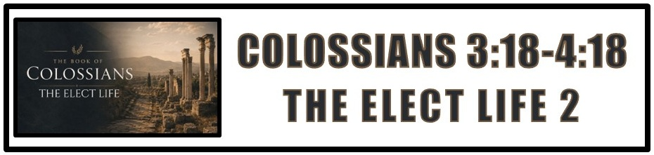
The Bottom Line:
Live Like You’re _____________!

Submit (3:18)
Hypotassō (Strong’s G5293)
I. to ______________ under, to subordinate

To submit “as to the Lord” means that submission is an act of ______________ to the Lord not subservience to a husband. (3:18, See Colossians 3:23)

Love (3:19)
Agapaō (Strong’s G25)
I. of persons
1. to welcome, to entertain, to be fond of, to ___________ _____________

Agape love is a choice. It is not earned or deserved. It is simply ____________. (3:19)

The gift of submission is facilitated in the _________________ of the gift of love. (3:19)

The ________________ and not ______________ giving of submission and love is the facilitator of a godly and healthy marriage. (VS 19)

Children who ____________ their parents are equipped with the wisdom and knowledge to be successful and productive in God’s purpose for them. (3:20-21)

Parents are to raise their children in the ways of God, not only through good teaching but by ____________ ______________. (3:20-21, 2 Timothy 1:5)

Mature believers understand that ____________ __________ of life is an opportunity to worship and honor God. (3:22-4:1)

__________ sees and knows how we treat others, and how we treat others reflects our relationship with Him. (3:22-4:1)

The purpose and plans of God play out in response to the ________________ or ______________ of the prayer of God’s people. (4:2-4)

The mature believer will always walk in wisdom, carefully and not carelessly, that they may be a ____________ ______________ for Christ.

Notes:
________________________________________________________________________________________________________________________________________________________________________________________________________________________________________________________________________________________________________________________________________________________________________________________________________________________________________________________________________________________________________________________________________________________________________________________________________________________________________________________________________________________________________________________________________________________________________________________________________________________________________________________________________________________________________________________________________________________________________________________________________________________________________________________________________________________________________________________________________________________________________________________________________________________________________________________________________________________________________________________________________________________________________________________________________________________________________________________________________________________________________________________________________________________________________________________________________________________________________________________________________________________________________________________________________________________________________________________________________________________________________________________________________________________________________________________________________________________________________________________________________________________________________________________________________________________________________________________________________________________________________________________________________________________________________________________________________________________________________________________________________________________________________________________________________________________________________________________________________________________________________________________________________________________________________________________________________________________________________________________________________________________________________________________________________________________________________________________________________________________________________________________________________________________________________________________________________________________________________________________________________________________________________________________________________________________________________________________________________________________________________________________________________________________________________________________________________________________________________________________________________________________________________________________________________________________________________________________________________________________________________________________________________________________________________________________________________________________________________________________________________________________________________________________________________________________________________________________________________________________________________________________________________________________________________________________________________________________________________________________________________________________________________________________________________________________________________________________________________________________________________________________________________________________________________________________________________________________________________________________________________________________________________________________________________________________________________________________________________________________________________________________________________________________________________________________________________________________________________________________________________________________________________________________________________________________________________________________________________________________________________________________________________________________________

